Year | Jan | Feb. | Mar. | Apr. | May | June | July | Aug. | Sep. | Oct. | Nov. | Dec. | Total
2014 | 17 | 20 | 17 | 18 | 16 | 10 | 4 | 7 | 5 | 13 | 13 | 14 | 154
2015 | 20 | 6 | 4 | 38 | 54 | 51 | 17 | 15 | 5 | 5 | 4 | 0 | 219
2016 | 4 | 9 | 8 | 4 | 7 | 6 | 19 | 23 | 6 | 12 | 9 | 18 | 125
2017 | 82 | 84 | 39 | 26 | 17 | 8 | 17 | 13 | 28 | 27 | 53 | 63 | 457
2018 | 73 | 105 | 185 | 251 | 169 | 73 | 69 | 34 | 39 | 52 | 51 | 55 | 1,156
2019 | 292 | 424 | 157 | 62 | 19 | 26 | 14 | 13 | 1 | 3 | 12 | 1 | 1,024
2020 | 5 | 8 | 12 | 7 | 1 | 0 | 0 | 0 | 0 | 0 | 0 | 1 | 34
2021 | 0 | 1 | 2 | 0 | 3 | 3 | 1 | 1 | 67 | 123 | 96 | 30 | 327
2022 | 18 | 3 | 6 | 1 | 10 | 33 | 15 | 39 | 40 | 20 | 27 | 35 | 247
2023 | 110 | 161 | 400 | 351 | 372 | 243 | 191 | 152 | 96 | 71 | 47 | 60 | 2,254
Total | 621 | 821 | 830 | 758 | 668 | 453 | 347 | 297 | 287 | 326 | 312 | 277 | 5,997

Year | Age group (years)
 | <1 | 1 - < 5 | 5 - < 15 | 15 - < 45 | ≥ 45 | Total
2014 | 33 | 55 | 26 | 35 | 5 | 154
2015 | 65 | 73 | 21 | 55 | 5 | 219
2016 | 33 | 43 | 16 | 28 | 5 | 125
2017 | 164 | 132 | 58 | 90 | 13 | 457
2018 | 356 | 436 | 188 | 170 | 6 | 1,156
2019 | 403 | 391 | 122 | 97 | 11 | 1,024
2020 | 4 | 14 | 12 | 4 | 0 | 34
2021 | 94 | 120 | 25 | 86 | 2 | 327
2022 | 49 | 88 | 40 | 68 | 2 | 247
2023 | 561 | 916 | 565 | 185 | 27 | 2,254
Total | 1,762 | 2.268 | 1,073 | 700 | 76 | 5,843

Figure 2a: Annual age-specific incidence rates of reported measles cases in Saudi Arabia, 2014–2023.
Year | <1 | 1–<5 | 5–<15 | 15–<45 | ≥45
2014 | 5.78 | 2.52 | 0.56 | 0.2 | 0.11
2015 | 11.28 | 3.29 | 0.45 | 0.31 | 0.11
2016 | 5.66 | 1.91 | 0.33 | 0.16 | 0.1
2017 | 27.9 | 5.83 | 1.19 | 0.51 | 0.25
2018 | 61.14 | 19.28 | 3.8 | 0.98 | 0.11
2019 | 71.17 | 17.41 | 2.42 | 0.56 | 0.21
2020 | 0.74 | 0.63 | 0.23 | 0.02 | 0
2021 | 18.31 | 5.56 | 0.48 | 0.48 | 0.04
2022 | 9.84 | 4.16 | 0.75 | 0.37 | 0.03
2023 | 107.23 | 43.83 | 10.46 | 0.97 | 0.43
* Values represent reported measles cases per 100,000 population within each age group and year.
* Darker shading indicates higher age-specific incidence rates
Figure 2b: Average annual incidence rate of measles by age group, Saudi Arabia, 2014–2023
Year | Jan | Feb. | Mar. | Apr. | May | June | July | Aug. | Sep. | Oct. | Nov. | Dec. | Total
2014 | 17 | 20 | 17 | 18 | 16 | 10 | 4 | 7 | 5 | 13 | 13 | 14 | 154
2015 | 20 | 6 | 4 | 38 | 54 | 51 | 17 | 15 | 5 | 5 | 4 | 0 | 219
2016 | 4 | 9 | 8 | 4 | 7 | 6 | 19 | 23 | 6 | 12 | 9 | 18 | 125
2017 | 82 | 84 | 39 | 26 | 17 | 8 | 17 | 13 | 28 | 27 | 53 | 63 | 457
2018 | 73 | 105 | 185 | 251 | 169 | 73 | 69 | 34 | 39 | 52 | 51 | 55 | 1,156
2019 | 292 | 424 | 157 | 62 | 19 | 26 | 14 | 13 | 1 | 3 | 12 | 1 | 1,024
2020 | 5 | 8 | 12 | 7 | 1 | 0 | 0 | 0 | 0 | 0 | 0 | 1 | 34
2021 | 0 | 1 | 2 | 0 | 3 | 3 | 1 | 1 | 67 | 123 | 96 | 30 | 327
2022 | 18 | 3 | 6 | 1 | 10 | 33 | 15 | 39 | 40 | 20 | 27 | 35 | 247
2023 | 110 | 161 | 400 | 351 | 372 | 243 | 191 | 152 | 96 | 71 | 47 | 60 | 2,254
Total | 621 | 821 | 830 | 758 | 668 | 453 | 347 | 297 | 287 | 326 | 312 | 277 | 5,997

Year | Jan | Feb. | Mar. | Apr. | May | June | July | Aug. | Sep. | Oct. | Nov. | Dec.
2014 | 17 | 20 | 17 | 18 | 16 | 10 | 4 | 7 | 5 | 13 | 13 | 14
2015 | 20 | 6 | 4 | 38 | 54 | 51 | 17 | 15 | 5 | 5 | 4 | 0
2016 | 4 | 9 | 8 | 4 | 7 | 6 | 19 | 23 | 6 | 12 | 9 | 18
2017 | 82 | 84 | 39 | 26 | 17 | 8 | 17 | 13 | 28 | 27 | 53 | 63
2018 | 73 | 105 | 185 | 251 | 169 | 73 | 69 | 34 | 39 | 52 | 51 | 55
2019 | 292 | 424 | 157 | 62 | 19 | 26 | 14 | 13 | 1 | 3 | 12 | 1
2020 | 5 | 8 | 12 | 7 | 1 | 0 | 0 | 0 | 0 | 0 | 0 | 1
2021 | 0 | 1 | 2 | 0 | 3 | 3 | 1 | 1 | 67 | 123 | 96 | 30
2022 | 18 | 3 | 6 | 1 | 10 | 33 | 15 | 39 | 40 | 20 | 27 | 35
2023 | 110 | 161 | 400 | 351 | 372 | 243 | 191 | 152 | 96 | 71 | 47 | 60

Region | 2014 | 2015 | 2016 | 2017 | 2018 | 2019 | 2020 | 2021 | 2022 | 2023 | Total
Riyadh | 15 | 11 | 5 | 45 | 272 | 21 | 23 | 1 | 50 | 1157
Makkah | 6 | 15 | 5 | 18 | 32 | 13 | 0 | 297 | 72 | 87
Jeddah | 52 | 11 | 3 | 65 | 231 | 17 | 7 | 14 | 22 | 67
Ta`if | 11 | 6 | 4 | 8 | 72 | 4 | 0 | 2 | 1 | 52
Medinah | 11 | 60 | 28 | 9 | 34 | 23 | 1 | 0 | 3 | 131
Qaseem | 5 | 2 | 6 | 0 | 20 | 26 | 0 | 0 | 1 | 144
Eastern | 23 | 8 | 10 | 17 | 72 | 4 | 1 | 1 | 26 | 92
Al-Ahsa | 4 | 1 | 2 | 3 | 13 | 2 | 0 | 0 | 3 | 23
Hafr Al-Baten | 1 | 0 | 0 | 0 | 18 | 2 | 0 | 0 | 6 | 9
Aseer | 2 | 3 | 5 | 27 | 130 | 30 | 0 | 6 | 8 | 42
Bishah | 0 | 0 | 1 | 0 | 22 | 0 | 0 | 0 | 1 | 1
Tabouk | 2 | 12 | 6 | 7 | 9 | 14 | 0 | 1 | 6 | 59
Ha`il | 1 | 29 | 0 | 0 | 0 | 0 | 0 | 0 | 4 | 12
Northern | 2 | 3 | 8 | 5 | 3 | 2 | 0 | 2 | 18 | 12
Jazan | 3 | 5 | 7 | 64 | 80 | 109 | 2 | 2 | 10 | 40
Najran | 12 | 48 | 14 | 183 | 18 | 21 | 0 | 0 | 2 | 305
Al-Bahah | 0 | 1 | 1 | 1 | 1 | 1 | 0 | 0 | 5 | 6
Al-Jouf | 3 | 3 | 13 | 5 | 25 | 510 | 0 | 0 | 3 | 5
Qurayyat | 1 | 0 | 7 | 0 | 90 | 207 | 0 | 1 | 5 | 6
Qunfudah | 0 | 1 | 0 | 0 | 14 | 18 | 0 | 0 | 1 | 4
Total | 154 | 219 | 125 | 457 | 1,156 | 1024 | 34 | 327 | 247 | 2,254

Figure 4: Average annual measles incidence by health region Saudi Arabia, 2014 -2023 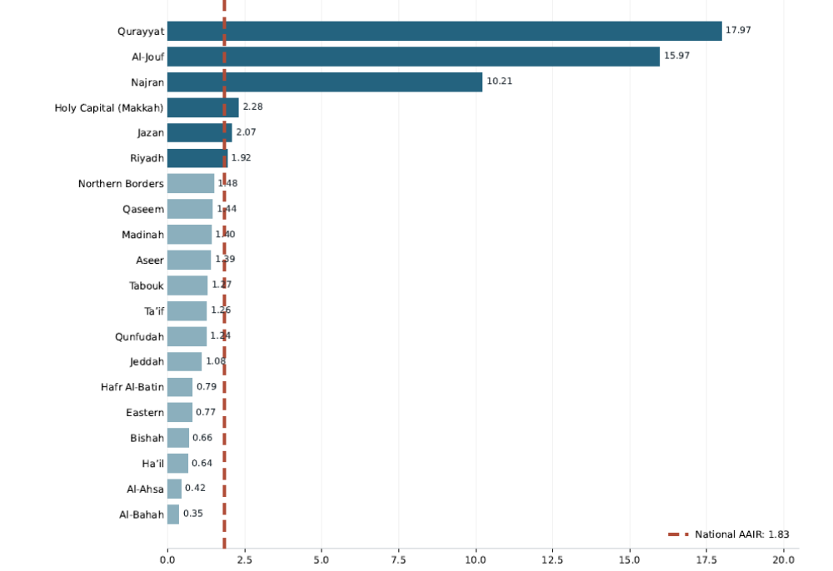
National AAIR = 1.83
Reported measles cases per 100,000 population per year
National AAIR = 5,997 cases ÷ (32,694,320 mean annual population × 10 years) × 100,000 = 1.83/100,000 population/year

